# Ryan Timbrook

## IST 659 Data Admin Concepts &Db Mgmt

## Date: 9/10/2018

## Lab Assignment: Lab 9, Data Security

## Description / Learning Objective

* Demonstrate proficiency in creating database users and administering to their user privileges on database objects
* Demonstrate proficiency in preserving data integrity using transactions

## Responses

### Part 1 - Securing Data Objects

P1-TODO-1: Creating a Database User

P1-TODO-1: Screen Prints

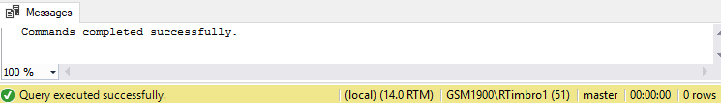

P1-TODO-1: Code Snippet



P1-TODO-2: Managing a User’s Permissions

P1-TODO-2a: vc_UserLogin Table

P1-TODO-2a: Screen Prints

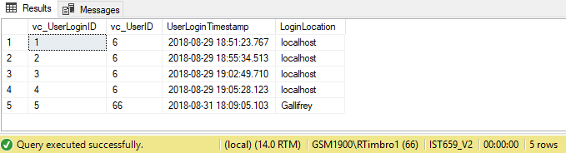

P1-TODO-2b: vc_VidCast records

P1-TODO-2b: Screen Prints

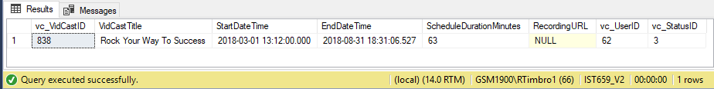

P1-TODO-2: Code Snippets - my tab

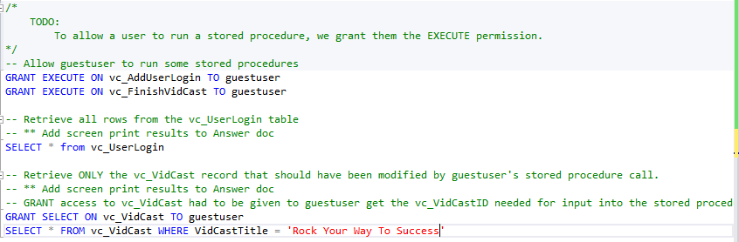

P1-TODO-2: Code Snippets – guestuser tab

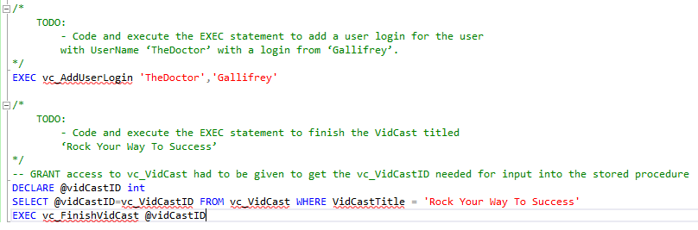

### Part 2 – Data Integrity Through Transactions

P2-TODO-1:

P2-TODO-1: Screen Prints

|  |  |
| --- | --- |
| First Run: With Expected Error | Second Run: Without Error |

P2-TODO-1: Question/Answer

Q: Explain the reason the first execution failed, but the second did not.

A: There was already a record with the value of ‘One’ as the lab_testText. There’s a unique constraint that prevents us from adding another record with the same value.

Error Message Response: “Violation of UNIQUE KEY constraint 'UQ__lab_Test__0C6272FF5747EE6F'. Cannot insert duplicate key in object 'dbo.lab_Test'. The duplicate key value is (One).”

Q: Was there anything that happened that you didn’t expect?

A: No, everything executed as expected

P2-TODO-1: Code Snippet

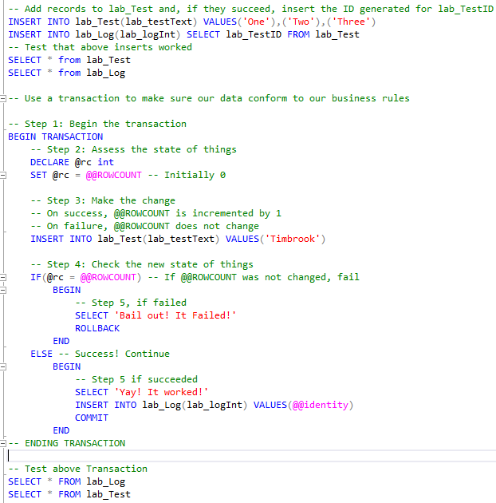

## Code Submission

#### my tab:

|  |
| --- |
| /*  IST 659 Data Admin Concepts &Db Mgmt  Date: 9/10/2018  Lab Assignment: Lab 9, Data Security  */  /*  TODO:  Create Guest User  */  -- Creating a guestuser database user  CREATE USER guestuser FOR LOGIN guestuser  /*  TODO:  Grant read permissions  */  -- Grant read permission on the user table  GRANT SELECT ON vc_User to guestuser  /*  TODO:  Code and execute the following statements to revoke the select permission  on vc_User and grant the select permission on the vc_MostProlificUsers view.  */  -- Revoke the select permissions  REVOKE SELECT ON vc_User to guestuser  -- Give them the view instead  GRANT SELECT ON vc_MostProlificUsers to guestuser  /*  TODO:  To allow a user to run a stored procedure, we grant them the EXECUTE permission.  */  -- Allow guestuser to run some stored procedures  GRANT EXECUTE ON vc_AddUserLogin TO guestuser  GRANT EXECUTE ON vc_FinishVidCast TO guestuser  -- Retrieve all rows from the vc_UserLogin table  -- ** Add screen print results to Answer doc  SELECT * from vc_UserLogin  -- Retrieve ONLY the vc_VidCast record that should have been modified by guestuser's stored procedure call.  -- ** Add screen print results to Answer doc  -- GRANT access to vc_VidCast had to be given to guestuser get the vc_VidCastID needed for input into the stored procedure  GRANT SELECT ON vc_VidCast TO guestuser  SELECT * FROM vc_VidCast WHERE VidCastTitle = 'Rock Your Way To Success'  /*  Part 2 – Data Integrity Through Transactions  The Setup:  We’re going to set up two simple tables separate from our VidCast tables to mess with.  */  -- Creating a new table  CREATE TABLE lab_Test(  lab_TestID int identity primary key,  lab_testText varchar(20) unique not null  )  /*  This will be a table to keep a log of created lab_Test records.  We don't want to add a row to this if the insert into lab_Test fails  */  CREATE TABLE lab_Log(  lab_LogID int identity primary key,  lab_logInt int unique not null  )  -- Add records to lab_Test and, if they succeed, insert the ID generated for lab_TestID  INSERT INTO lab_Test(lab_testText) VALUES('One'),('Two'),('Three')  INSERT INTO lab_Log(lab_logInt) SELECT lab_TestID FROM lab_Test  -- Test that above inserts worked  SELECT * from lab_Test  SELECT * from lab_Log  -- Use a transaction to make sure our data conform to our business rules  -- Step 1: Begin the transaction  BEGIN TRANSACTION  -- Step 2: Assess the state of things  DECLARE @rc int  SET @rc = @@ROWCOUNT -- Initially 0  -- Step 3: Make the change  -- On success, @@ROWCOUNT is incremented by 1  -- On failure, @@ROWCOUNT does not change  INSERT INTO lab_Test(lab_testText) VALUES('Timbrook')  -- Step 4: Check the new state of things  IF(@rc = @@ROWCOUNT) -- If @@ROWCOUNT was not changed, fail  BEGIN  -- Step 5, if failed  SELECT 'Bail out! It Failed!'  ROLLBACK  END  ELSE -- Success! Continue  BEGIN  -- Step 5 if succeeded  SELECT 'Yay! It worked!'  INSERT INTO lab_Log(lab_logInt) VALUES(@@identity)  COMMIT  END  -- ENDING TRANSACTION  -- Test above Transaction  SELECT * FROM lab_Log  SELECT * FROM lab_Test |

#### guestuser tab:

|  |
| --- |
| /*  IST 659 Data Admin Concepts &Db Mgmt  Date: 9/10/2018  Lab Assignment: Lab 9, Data Security  **** GUEST USER ****  */  -- Guestuser's tab  SELECT * FROM vc_User  /*  Above select privilages to the vc_User table were revoked.  In replace of direct access to the vc_User table, select privilages were granted  to the vc_MostProlificUsers view.  */  -- Access granted to view  SELECT * FROM vc_MostProlificUsers  /*  TODO:  - Code and execute the EXEC statement to add a user login for the user  with UserName ‘TheDoctor’ with a login from ‘Gallifrey’.  */  EXEC vc_AddUserLogin 'TheDoctor','Gallifrey'  /*  TODO:  - Code and execute the EXEC statement to finish the VidCast titled  ‘Rock Your Way To Success’  */  -- GRANT access to vc_VidCast had to be given to get the vc_VidCastID needed for input into the stored procedure  DECLARE @vidCastID int  SELECT @vidCastID=vc_VidCastID FROM vc_VidCast WHERE VidCastTitle = 'Rock Your Way To Success'  EXEC vc_FinishVidCast @vidCastID |